Assignment No.2

PRN :- 123B1B230

Name :- Shailesh Pawar

1. Create StudentManagement database

CREATE DATABASE StudentManagement;

USE StudentManagement;

2.Create the Students table under the StudentManagement database

create table students_230(

-> PRN INT PRIMARY KEY,

-> FirstName VARCHAR(50) NOT NULL,

-> LastName VARCHAR(50) NOT NULL,

-> MiddleName VARCHAR(50) NULL,

-> Year INT NOT NULL,

-> Email VARCHAR(100) UNIQUE,

-> Age INT NOT NULL,

-> Department VARCHAR(100) NOT NULL

-> );

3.Insert records into the Students table

INSERT INTO students_230 (PRN, FirstName, LastName, MiddleName, Year, Email, Age, Department)

VALUES

(101, 'John', 'Doe', 'A.', 2, 'john.doe@example.com', 20, 'Computer Science'),

(102, 'Jane', 'Smith', 'B.', 1, 'jane.smith@example.com', 19, 'Electronics'),

(103, 'Alice', 'Johnson', NULL, 3, 'alice.johnson@example.com', 21, 'Mechanical'),

(104, 'Brod', 'Stud', 'B', 2, 'Brod.a@example.com', 20, 'Electronics');

4.Write a query to retrieve all records from the Students table.

SELECT * FROM Students;

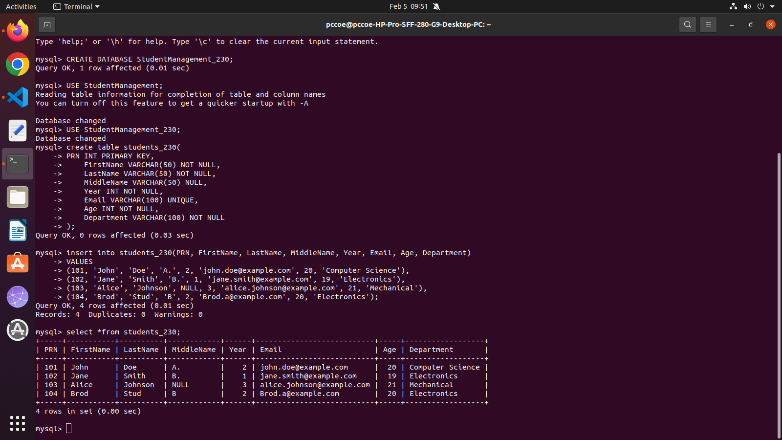

5.Write a query to update the Year of the student with PRN 102 to 2

UPDATE students_230

-> SET Year = 2

-> WHERE PRN = 102;

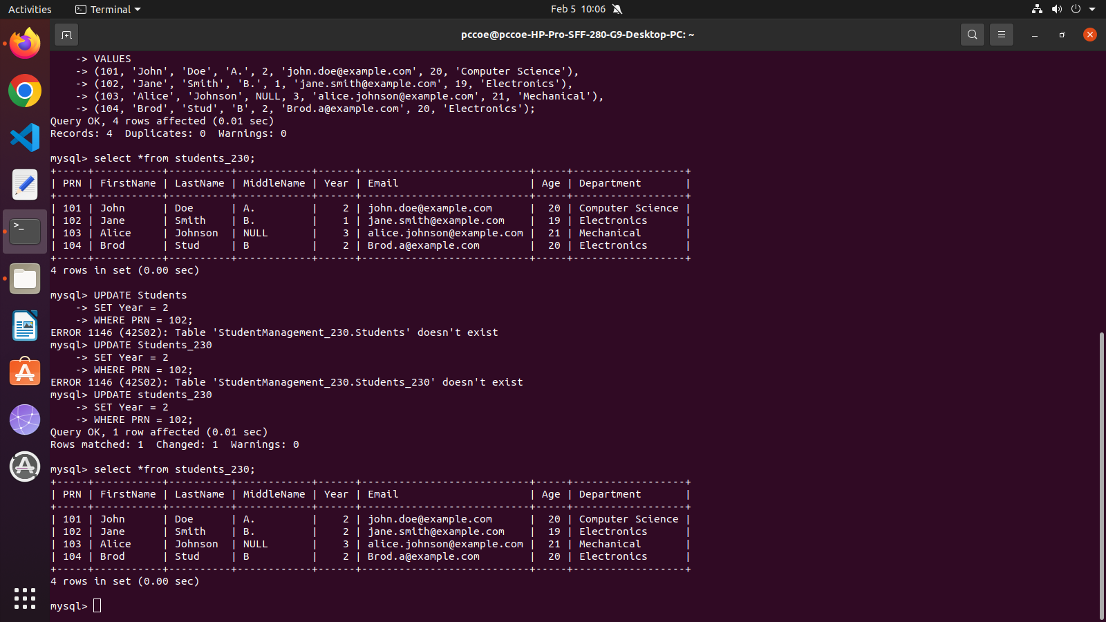

6.Write a query to delete the record of the student whose PRN is 103

DELETE FROM students_230

WHERE PRN = 103;

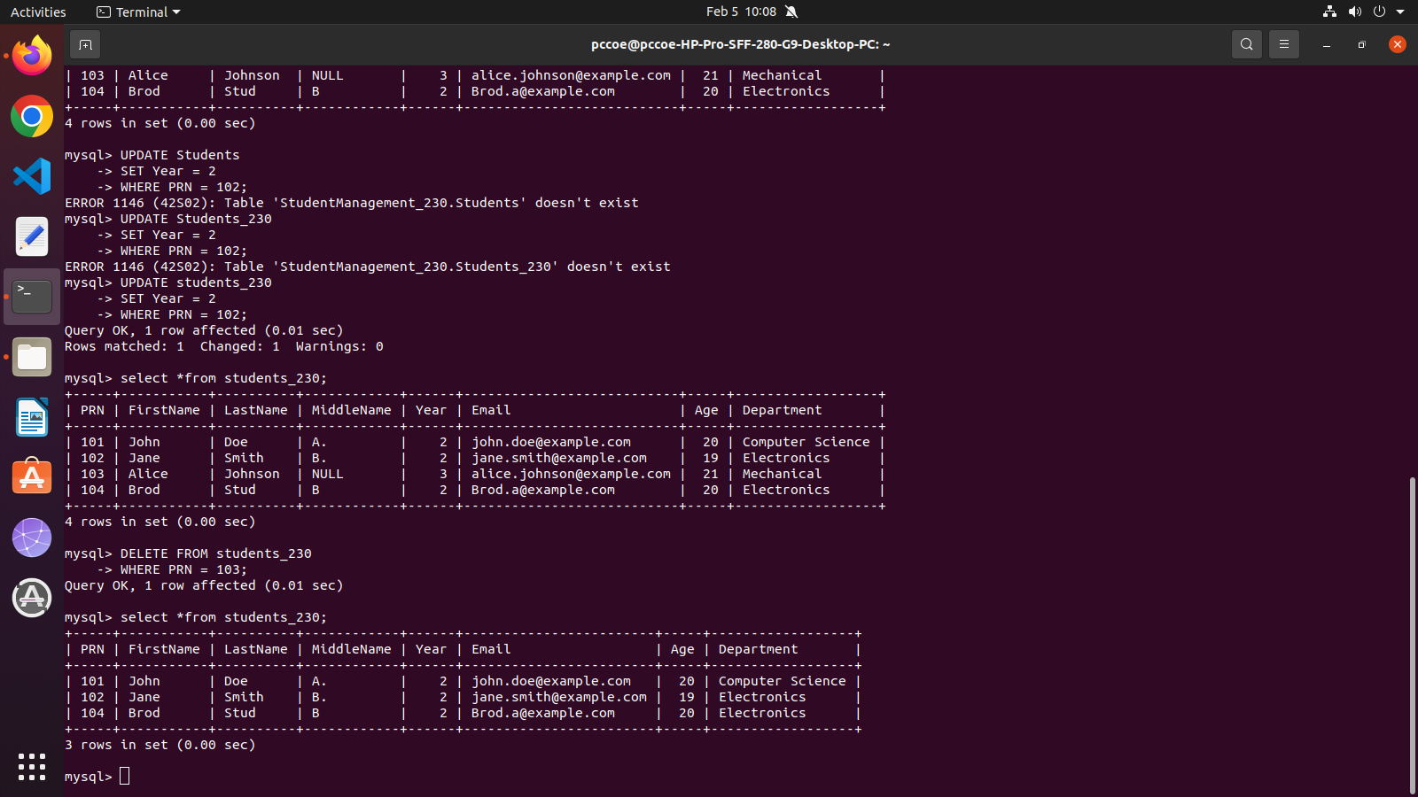

7.Write a query to delete the Students table from the StudentManagement database

DROP TABLE students_230;

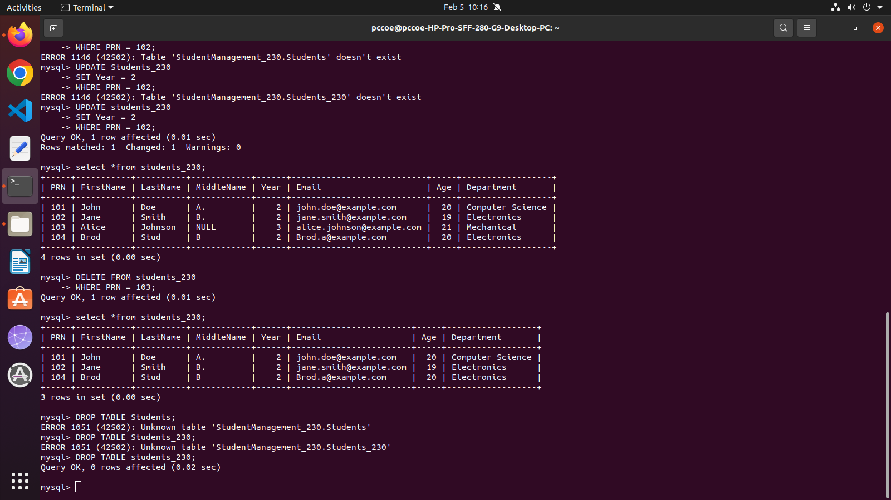

8.Alter the Students table - Add a new column PhoneNumber of type VARCHAR(15)

ALTER TABLE students_230

ADD COLUMN PhoneNumber VARCHAR(15);

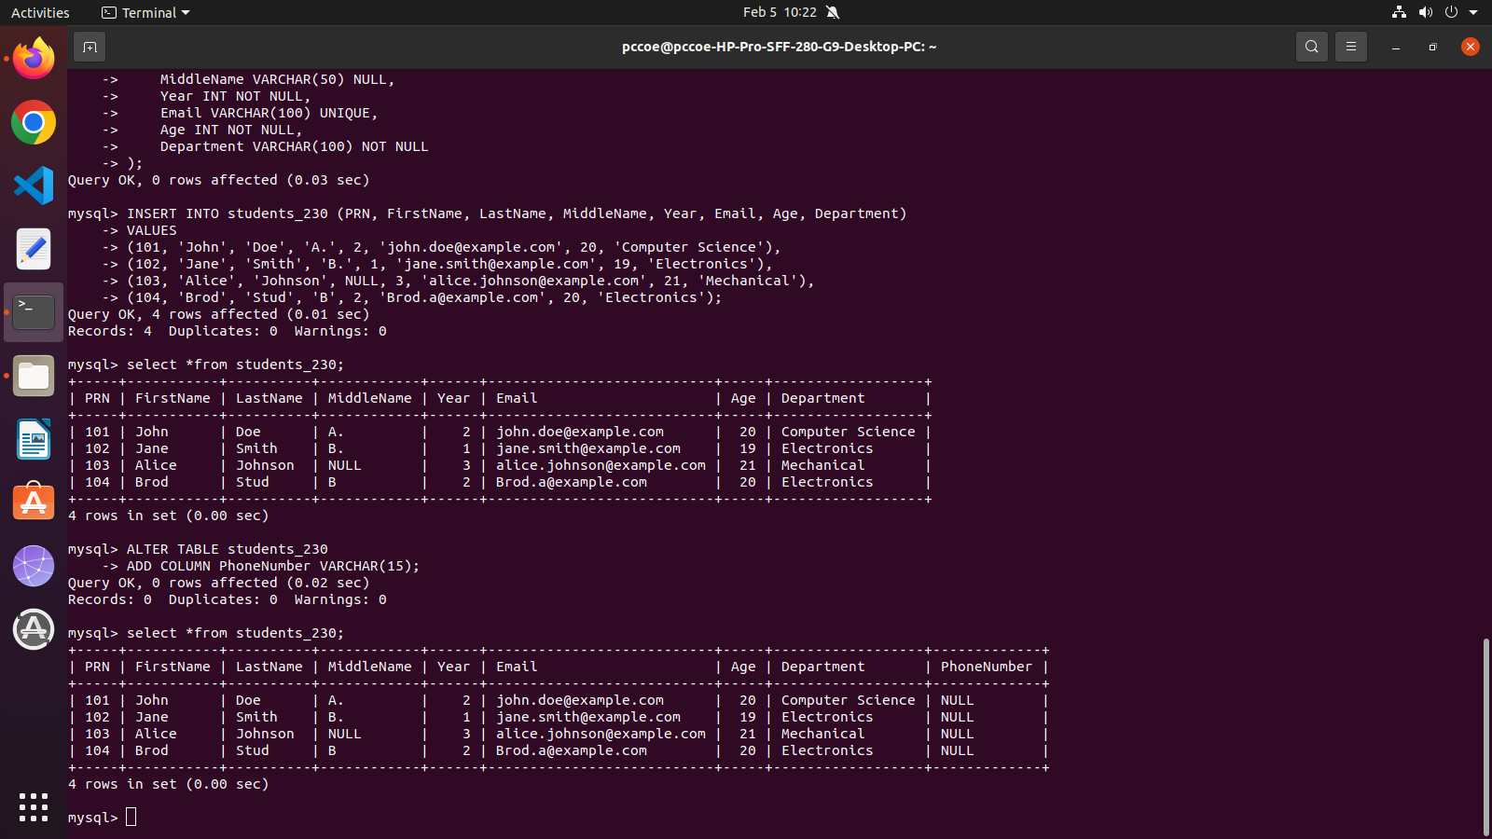

9. Write a query to retrieve all distinct departments from the Students table

SELECT DISTINCT Department FROM students_230;

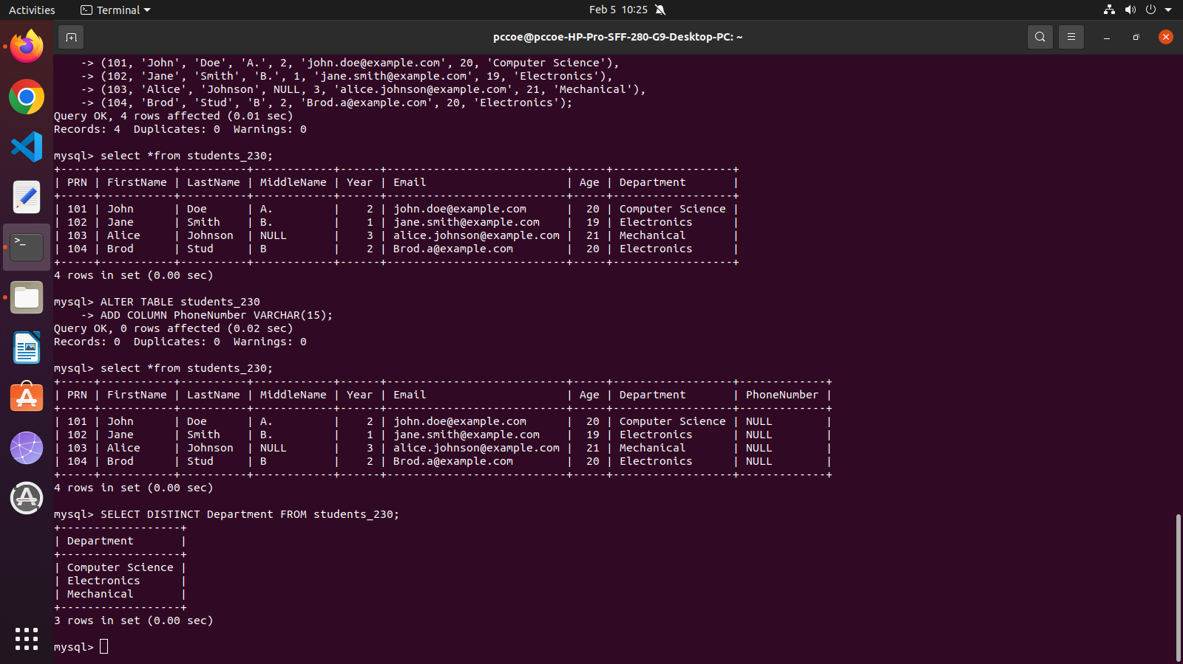

10. Write a query to find the number of distinct departments from the Students table

SELECT COUNT(DISTINCT Department) FROM students_230;

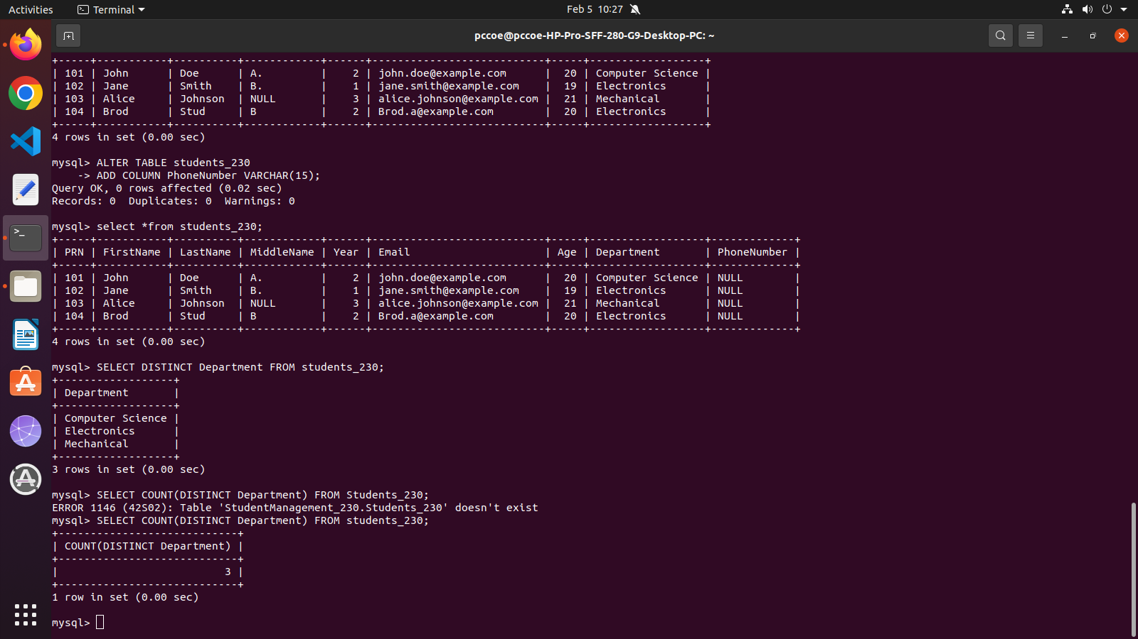

11. Write a query to retrieve the distinct years in which students are enrolled

SELECT DISTINCT Year FROM Students;

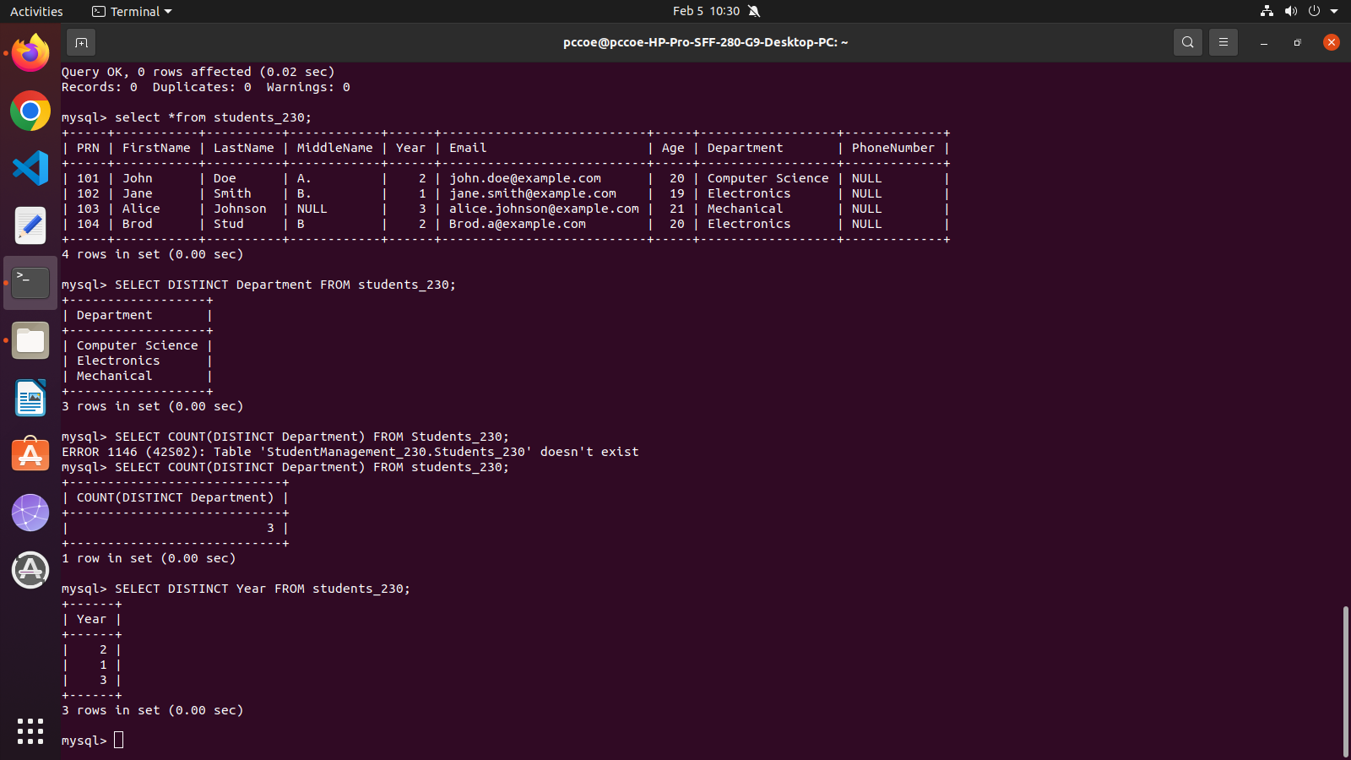

12. Write a query to retrieve all distinct ages of students in the "Computer Science" department

SELECT DISTINCT Age FROM students_230 WHERE Department = 'Computer Science';

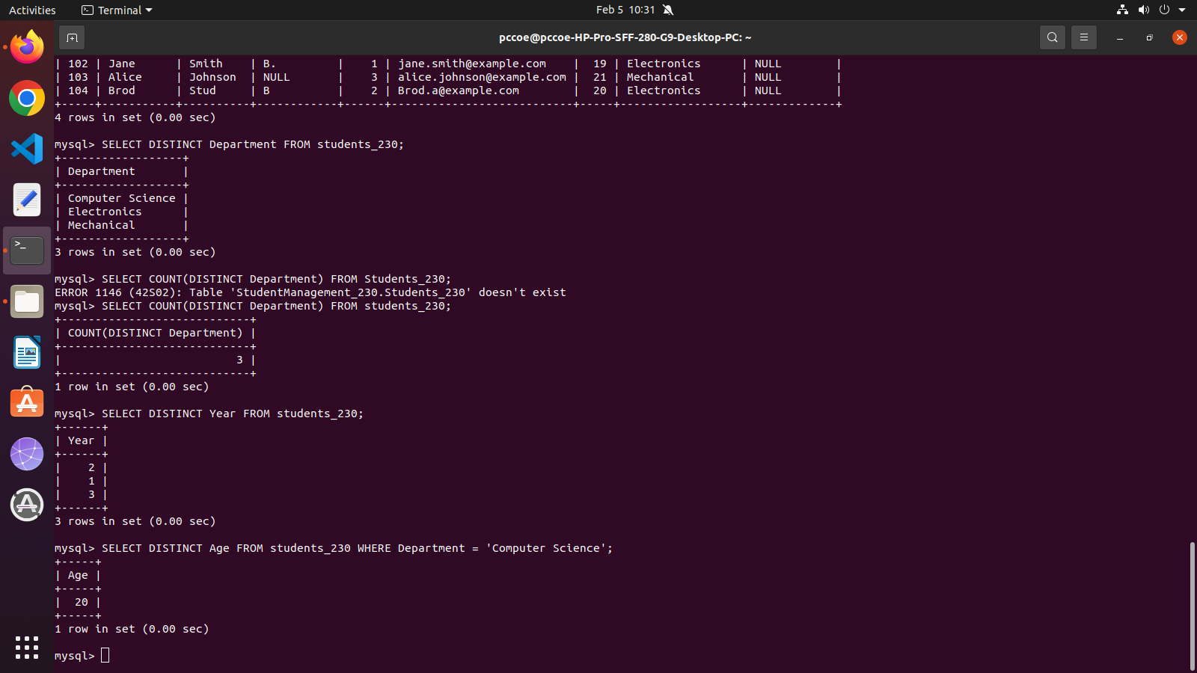

13. Write a query to retrieve distinct first names of students whose age is less than 21

SELECT DISTINCT FirstName FROM students_230 WHERE Age < 21;

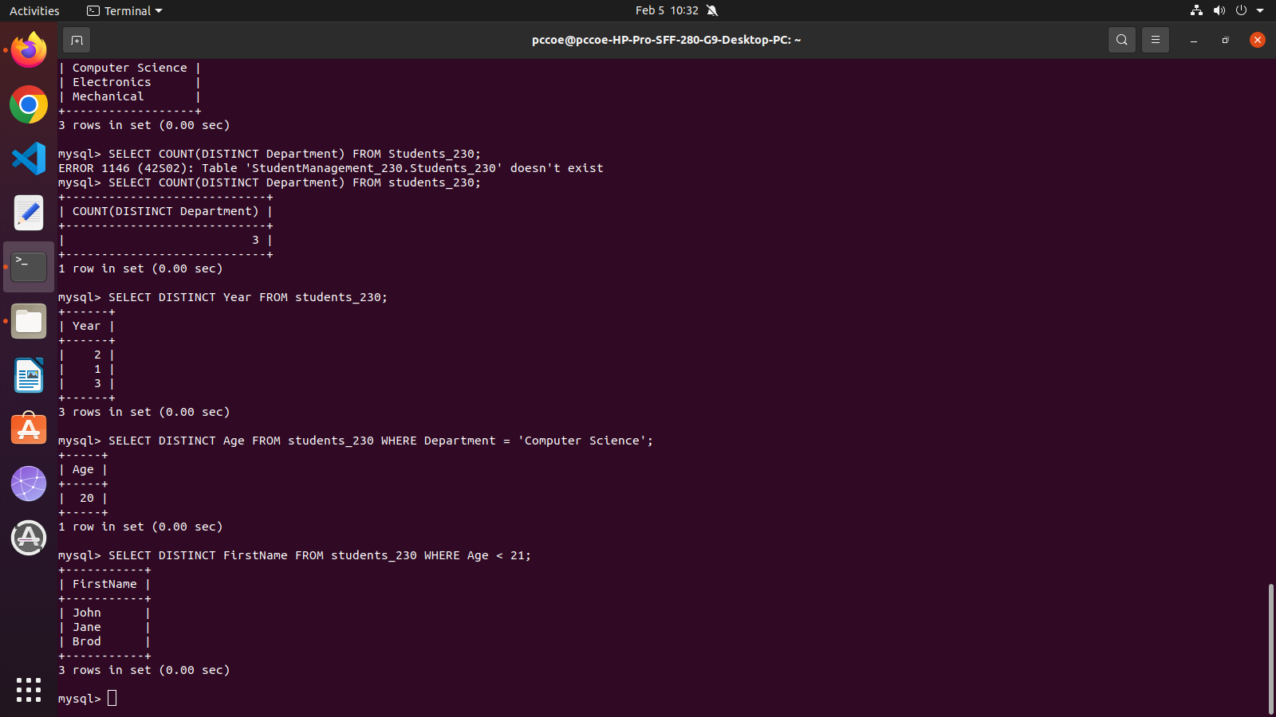

14. Write a query to retrieve the full details of students who are older than 20 years

SELECT * FROM students_230 WHERE Age > 20;

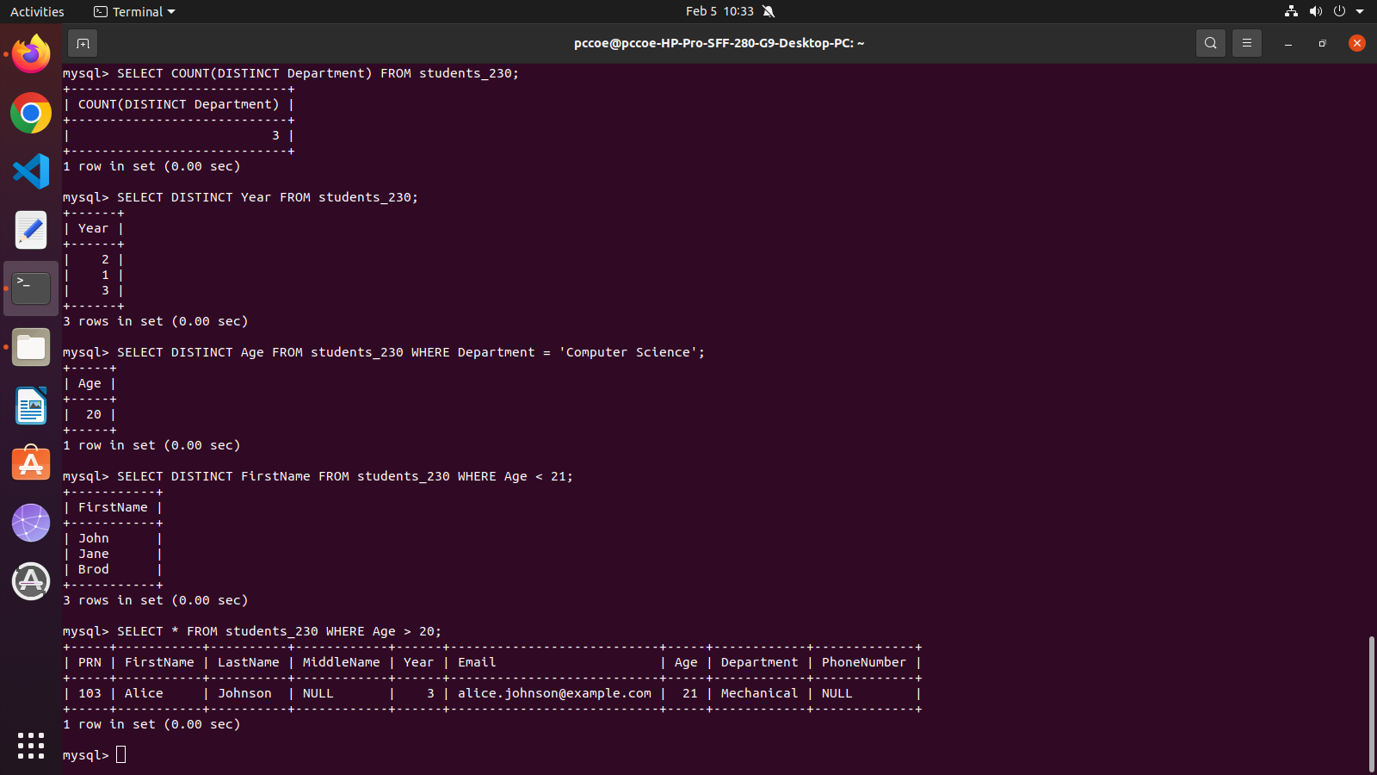

15. Write a query to retrieve all students enrolled in their third year

SELECT * FROM students_230 WHERE Year = 3;

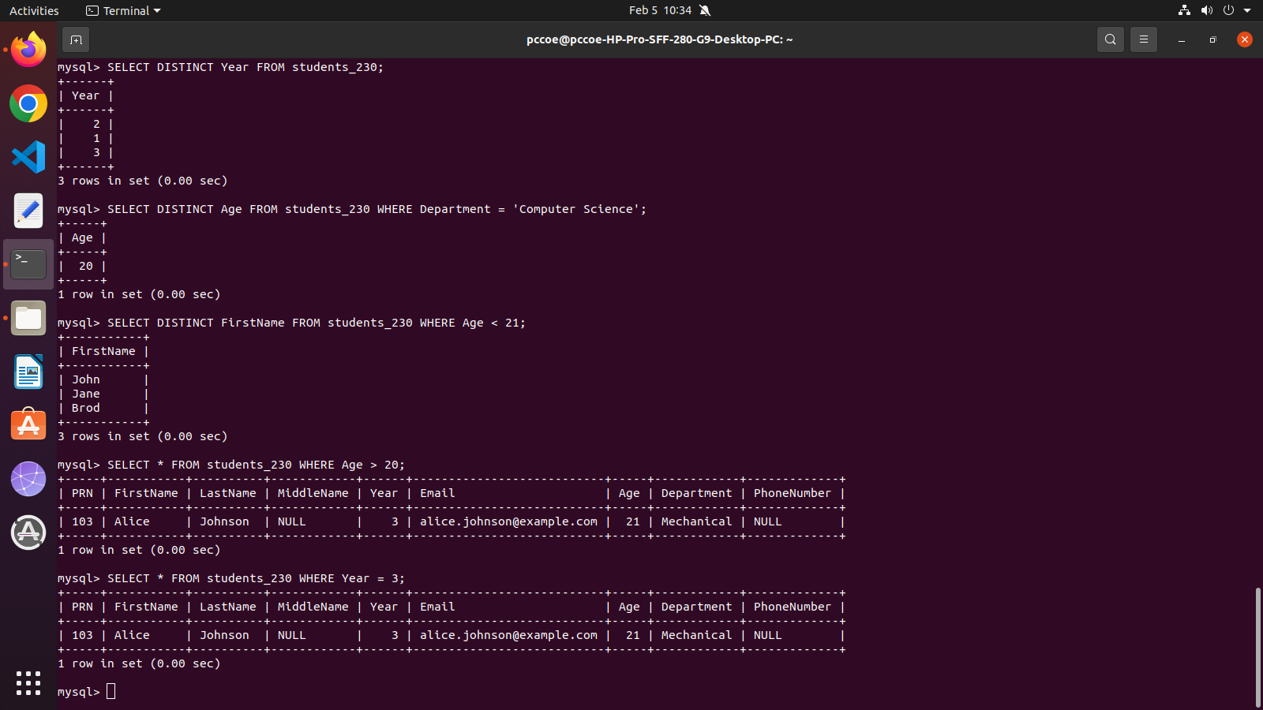

16. Write a query to display the first and last names of students along with their department, but only for students whose PRN is greater than 101.

SELECT FirstName, LastName, Department FROM students_230 WHERE PRN > 101;

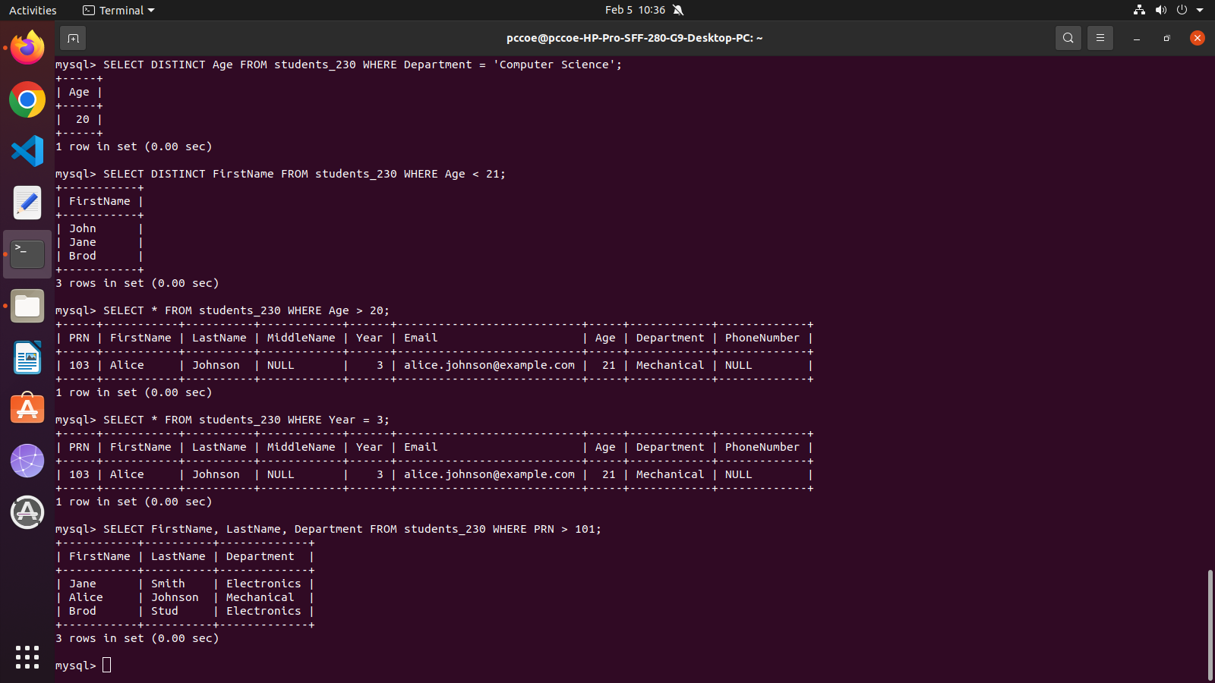

17. Write a query to fetch the first names and email addresses of all students in the "Electronics" department

SELECT FirstName, Email FROM students_230 WHERE Department = 'Electronics';

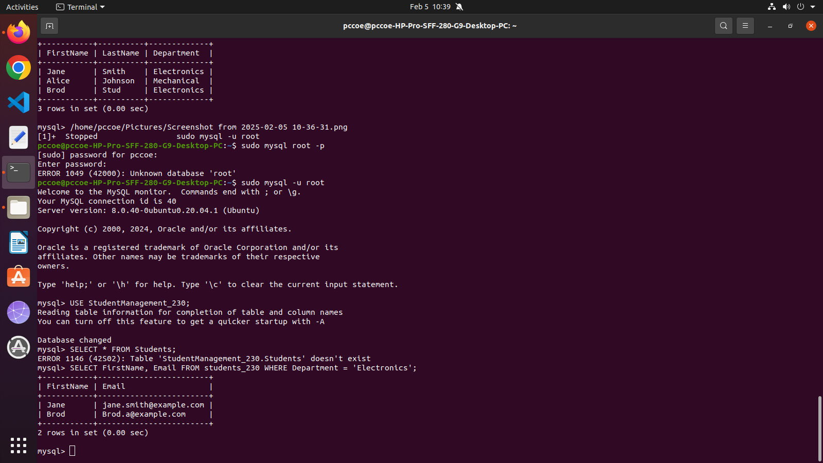

18. Write a query to fetch details of students in the "Computer Science" department who are older than 19

SELECT * FROM students_230 WHERE Department ='Computer Science' AND Age>19;

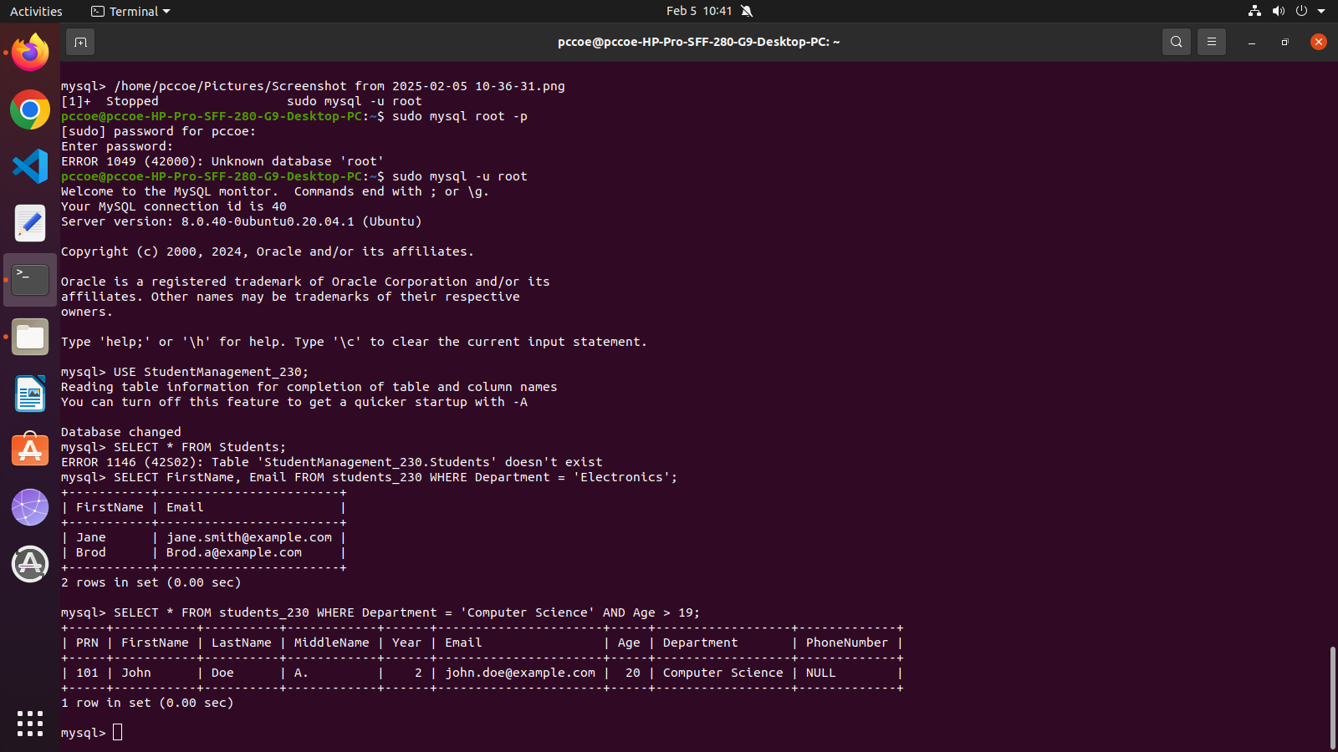

19. Write a query to remove all records from the Students table without deleting the structure of the table

TRUNCATE TABLE students_230;

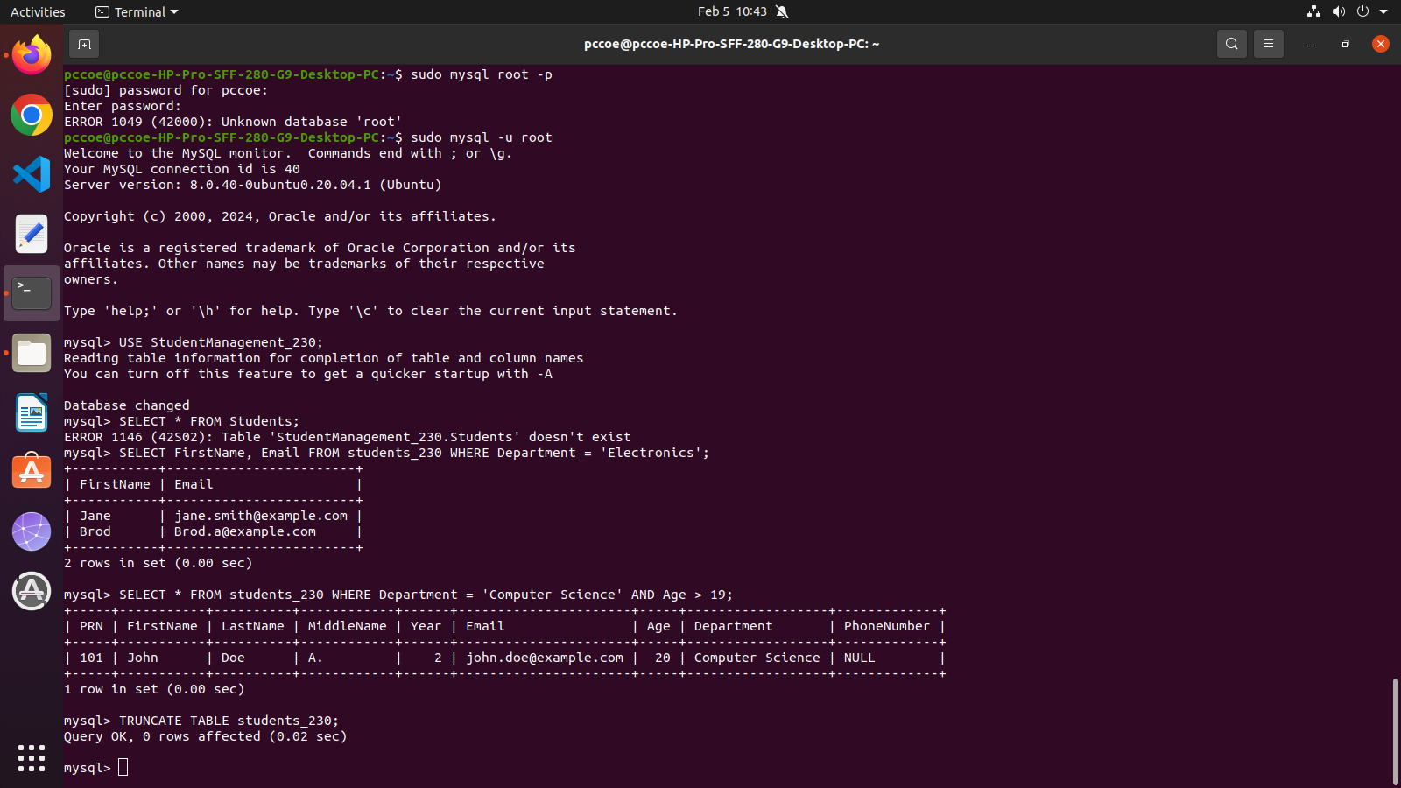

-- 20. Drop the Students table

DROP TABLE students_230;

